**COUNTDOWN CLOCK AND TIMER USING PYTHON**

A PROJECT REPORT

***Submitted by***

**Nikhil [192211031]**

**Syed Tausif [192021017]**

**Vineesha [192220064]**

*Under the guidance of*

**S. Raveena**

(Research Scholar, Department of Cognitive computing)

***in partial fulfillment for the completion of course CSA0812- PYTHON PROGRAMMING FOR WEB APPLICATIONS***



**SIMATS ENGINEERING**

**THANDALAM**

**MARCH 2024**

## BONAFIDE CERTIFICATE

Certified that this project report titled “**COUNTDOWN CLOCK AND TIMER**” is the bonafide work of “**NIKHIL [192211031], SYED TAUSIF [192021017], VINEESHA [192220064]”** who carried out the project work under my supervision as a batch. Certified further, that to the best of my knowledge the work reported herein does not form any other project report.

Date: project supervisor head of the department

TABLE OF CONTENT

|  |  |  |
| --- | --- | --- |
| **S.NO** | **CONTENT** | **PAGE NUMBER** |
| 1 | **ABSTRACT** | 6 |
| **2** | **INTRODUCTION** | 7-8 |
| **3** | **LITERATURE SURVEY** | 9-11 |
| **4** | **EXISTING WORK** | 11=13 |
| **5** | **PROPOSED MODEL** | 14-16 |
| **6** | **CONCLUSION** | 23 |
| **7** | **REFERENCES** | 24 |

TABLE OF CONTENTS

 ABSTRACT……………………………………………………………………………6-7

1.INTRODUCTION…………………………………………………………………….8-9

2. LITERATURE SURVEY…………………………………………………………….10

                2.1 Technological Advancements………………………………………………………………………..…10

                2.2 Effectiveness Evaluation……………………………………………………………………………….10

               2.3Regulatory Frameworks and Standards………………………………………………………………………………..11

               2.4Case Studies and Real-World Implementations………………………………………………………………...………11

**3.** EXISTING WORK…………………………………………………………………...13

           3.1. Conventional Timers and countdown clocks………………………………………………………….………………………..11

             3.2. Digital timers and countdown clocks…………………………………………………………………………………...11

             3.3. Countdown timer apps for mobile devices………………………………………………………………………………….11

             3.4. internet-based countdown timers…………………………………………………………………………………...11

             3.5. clever countdown

timer & clocks……………………………………………………………………….…11

3.6. AI-powered

timers and countdown clocks…………………………………………………………..11

3.7. commercial and industrial

timer options………………………………………………………………………...…11

4. PROPOSED MODEL……………………………………………………………….14

           4.1. Real-time Data Integration…………………………………………………………………………..…15

           4.2. Personalized Guidance……………………………………………………………………………….15

           4.3. User-Centered Design………………………………………………………………………………....15

=           4.4. Interoperability and Compatibility………………………………………………………………………….16

5. HARDWARE AND SOFTWARE………………………………………………….17

6. CODING…………………………………………………………………………….18-22

7. RESEARCH GAP………………………………………………………………......23

8.CONCLUSION………………………………………………………………………23

9. REFERENCES……………………………………………………………………..24

**ABBREVIATIONS**

IoT Internet of Things

I/O Input/Output

ABSTRACT

A countdown clock and a timer are essential tools for tracking and showing time in a number of applications. While a countdown clock counts down to zero after starting at a predetermined period, a timer counts up or down as it measures the amount of time elapsed from a beginning point. These devices are helpful for both everyday life and specialized fields including business, entertainment, and sports. The most basic kind of a countdown clock is an analogs or digital display that indicates how much time is left until a deadline or special event. Users can specify the initial duration and see a visual representation of the remaining time on the clock. In real time, the clock is counting down. Clocks that count down Timer devices offer an accurate way to measure elapsed time in a similar manner. They can be set to count down from a predetermined period or up from zero, showing the amount of time that has passed since the timer was started. Timers are commonly used to track progress, enforce time limitations, and monitor intervals in scientific investigations, sporting events, and production operations. Numerous technologies, such as digital displays, LED lights, mechanical mechanisms, and software programs, can be used to build countdown clocks and timers. Additional characteristics of contemporary digital countdown clocks and timers include numerous countdowns/timers, programmable alarms, remote control capabilities, and interaction with other systems and devices.

It includes the concept of precisely recording the passage of time in relation to a reference point that is set in time, such as the beginning point of a timer or the finish line of a countdown clock. The capacity of countdown clocks and timers to depict time as a measurable quantity, which promotes productivity, efficiency, and organization in a variety of settings, accounts for their abstract character.  
In summary, countdown clocks and timers perform significant roles in time management, measurement, and organization across many areas. Their abstract approach, which enables users to efficiently monitor and manage time in a variety of applications, is based on the core ideas of time tracking and representation.

**KEYWORDS:** Python Timer Library, Countdown Clock, User Interface, Event Handling, Threading and Concurrency, Alarm and Notification, Data Persistence, Testing and Debugging, Documentation and Documentation Tools.

 CHAPTER 1

INTRODUCTION:-

In many situations, from professional scheduling and event planning to personal time management, a countdown clock and timer are indispensable tools. While a timer keeps track of the amount of time spent on an ongoing task, a countdown clock shows the amount of time left until a certain event or deadline. With accurate timekeeping and timely notifications, both gadgets help users be more productive, efficient, and organized.

* Start by defining what a countdown clock and timer are. Explain that they are electronic devices or software applications used to measure and display the remaining time until a specified event or deadline.
* Highlight the widespread use of countdown clocks and timers in various contexts, including personal productivity, event management, sports, cooking, and industrial applications.
* Discuss the importance of countdown clocks and timers in helping individuals and organizations manage time effectively, stay organized, and meet deadlines. Emphasize how they contribute to efficiency, productivity, and performance improvement.

In contexts where timing is crucial, such athletic events, business presentations, exams, and space missions, countdown clocks are frequently utilized. They in still a sense of urgency and anticipation, which keeps participants motivated and focused while they work toward a specific objective. In daily life, countdown clocks can be used to keep track of the duration of significant events like birthday celebrations, vacations, and meetings.  
  
However, timers are adaptable devices that may be used for a variety of purposes, such as professional project management, academic work, cooking, and fitness regimens. With the use of timers, users may set aside certain periods of time for various tasks, making optimal use of available resources and making it easier to finish tasks by the deadline. Furthermore, timers are frequently used for repetitive chores.

The design and operation of countdown clocks and timers have undergone a radical change with the introduction of digital technology. In order to accommodate a wide range of user tastes and needs, modern gadgets come equipped with features that may be customized, such as visual displays, alarm alerts, and flexible time settings. Furthermore, a lot of electronic devices, including laptops, tablets, smartphones, and smartwatches, now come with built-in countdown clocks and timers, giving consumers easy access to timekeeping features wherever they are and whenever they need them.  
  
For efficient time management, productivity, and organization in a variety of personal, professional, and leisure activities, countdown clocks and timers are invaluable tools. These gadgets enable people to efficiently manage their calendars, fulfill deadlines, and accomplish their objectives by offering precise timekeeping, prompt notifications, and customized functionality.

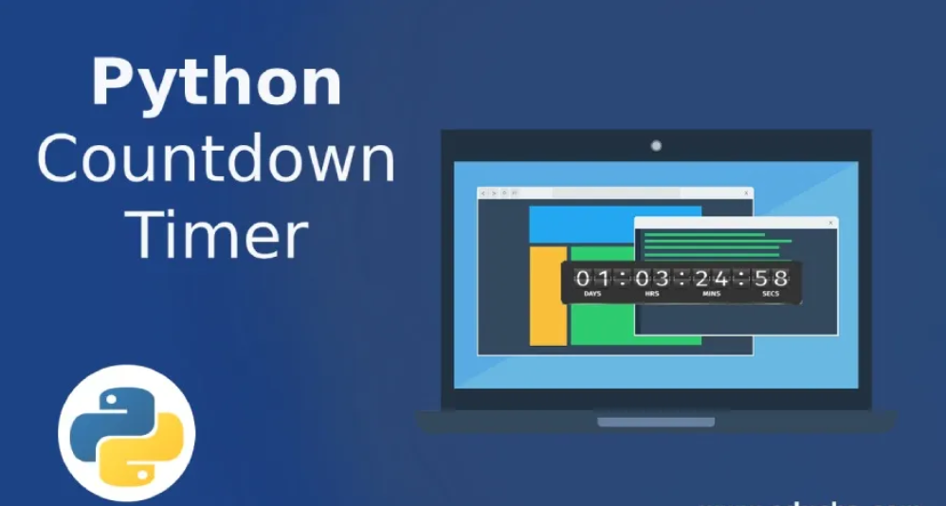

**Figure-1**: The above figure explain about the countdown clock and timer. Mainly it refers the working of countdown clock and timer

CHAPTER 2

LITERATURE SURVEY

Essential tools for a variety of applications, such as cooking, exams, presentations, and sporting events, are a countdown clock and timer. These technologies give consumers an audible and visual indication of the amount of time left before a deadline or event. Countdown clocks and timers have been the subject of much research, with studies addressing design, implementation, usability, and effectiveness, among other subjects.  
  
The design and use of countdown clocks and timers on various platforms and gadgets is the focus of the literature review. To improve usability and user experience, researchers have looked into a variety of user interface designs, including progress bars, analog clocks, and digital displays. Furthermore, research has looked into how countdown timers can be easily incorporated into physical devices, websites, and mobile apps to give people easy access to time-tracking resources.

**2.1. Technological Advancements:**

1. Evaluating countdown clocks and timers' efficacy in enhancing task performance and time management is another facet of this field's research.

2.Research has looked at how time awareness tools affect motivation, stress levels, and productivity in various settings.

3.Countdown clocks have been studied in educational settings as a way to help students better manage their study time and finish assignments on time.

**2.2. Effectiveness Evaluation:**

* + 1. Evaluating countdown clocks and timers' efficacy in enhancing task performance and time management is another facet of this field's research.
    2. Research has looked at how time awareness tools affect motivation, stress levels, and productivity in various settings. For instance, countdown clocks have been studied in educational settings as a way to help students better manage their study time and finish assignments on time.

**2.3. Regulatory Frameworks and Standards:**

* Moreover, the literature on timers and countdown clocks discusses how these tools might improve coordination, synchronization, and collaboration in group operations.
* Research has investigated the use of countdown timers to guarantee participant alignment and coordination in collaborative settings, including team sports, meetings, and synchronized performances.

**2.4. Case Studies and Real-World Implementations:**

* Assessing the effectiveness of timers and countdown clocks in improving work performance and time management constitutes another area of research in this topic.
* Studies have examined the effects of time awareness tools in a variety of contexts on stress, productivity, and motivation.
* In order to help students better manage their study time and turn in assignments on time, countdown clocks, for example, have been studied in educational contexts.

Furthermore, the literature on countdown clocks and timers addresses how these instruments could enhance cooperation, synchronization, and coordination in group activities. Countdown timers have been studied in relation to ensuring participant alignment and synchronization in group contexts such as team sports, meetings, and synchronized performances.

**Applications of AI in Countdown Clock and Timer:-**There are several ways that artificial intelligence (AI) can be used to improve the functionality, user experience, and add more features to countdown clocks and timers. AI is used in countdown clocks and timers in a few different ways, such as:

* **Predictive Scheduling**: AI systems are able to forecast tasks or events in the future by examining past data and user behavior. Users can better manage their time by using this information to dynamically change countdown timers depending on anticipated completion times.
* **Adaptive alerts**: AI-powered countdown timers with adaptive alerts are able to modify alert notifications in response to context and user activity. For example, the timer can learn to provide more frequent, attention-grabbing reminders if the user often delays or ignores alarms.
* **Natural Language Processing (NLP):** Timers and countdown clocks that employ NLP may comprehend user requests and react appropriately. The interface becomes more intuitive and user-friendly when users can engage with the timer using natural language, such as inquiring for the remaining time or setting countdown lengths.
* **Contextual Reminders:** AI can evaluate contextual data, including location information, calendar events, or user preferences, to deliver suggestions and reminders at the appropriate times. For instance, depending on the predicted cooking time and the current temperature settings, a cooking countdown timer may remind the user to preheat the oven.
* **Customized Recommendations:** Artificial intelligence systems are capable of analyzing user behavior and preferences to provide customized timer or countdown duration recommendations. For example, the system can recommend preset timers or ideal durations based on historical usage patterns if a user often sets timers for particular activities.
* **Task Automation:** Using preset rules or user preferences, AI-powered timers can automate routines or repetitive chores. Users can program automated countdown sequences, for instance, for their wake-up alarms, shower times, and breakfast preparation schedules.

CHAPTER 3

EXISTING WORK

Previous research on countdown clocks and timers has mostly concentrated on giving users the resources they need to efficiently manage time across a range of applications and domains. Originally designed as stand-alone appliances, traditional countdown clocks and timers were frequently found in offices, classrooms, and kitchens to help users keep track of deadlines or specified times. These early versions usually had limited functionality and basic analog or digital screens. But countdown clocks and timers have changed a lot since the introduction of digital technology and the broad use of computers.

Digital countdown clocks and timers have proliferated in recent years, appearing in a vast array of gadgets and software programs. Contemporary countdown timers come equipped with sophisticated features including multiple countdowns, preset timers, adjustable settings, and device syncing. They serve a variety of user demands and preferences and are frequently found in computers, wearables, smartphones, and Internet of Things (IoT) devices.   
  
Furthermore, new features for countdown clocks and timers have been made possible by developments in artificial intelligence (AI) and machine learning. Artificial intelligence (AI) enabled timers may evaluate user behaviour, forecast upcoming chores or events, and provide tailored timer setting recommendations. They can improve user experience and productivity by adaptively adjusting alert notifications based on context and user activities.

Furthermore, specialized applications and sectors are integrating countdown clocks and timers more and more. For instance, they are essential to industrial operations, scientific research, sporting events, and educational endeavors. Within these settings, countdown timers aid in task synchronization, workflow schedule management, safety compliance, and resource allocation that is both efficient and effective.   
  
All things considered, the work that has already been done on countdown clocks and timers demonstrates the intersection of technology innovation, user-centered design, and usefulness. Research and development efforts are concentrated on improving the functionality, usability, and integration of countdown clocks and timers across various domains and applications, as the need for effective time management tools keeps rising.

**3.1. Conventional Timers and Countdown Clocks:**

* Summary of countdown clocks, both digital and mechanical, that are traditional.
* The characteristics and constraints of individual timing gadgets.

**3.2. Digital Timers and Countdown Clocks:**

* + Digital countdown timers in electronics have evolved throughout time.
  + The characteristics and capabilities of electronic countdown clocks.
  1. **Countdown timer apps for mobile devices:**
  + An overview of tablet and smartphone countdown timer apps.
  + Popular timer apps are analyzed, along with their functionality.

**3.4. Internet-based countdown timers:**

* + Analysis of web-based countdown clock widgets and tools.
  + The integration of web-based clocks into websites and online platforms is discussed.

**3.5. Clever Countdown Timers & Clocks:**

* + An introduction to Internet of Things-capable smart timer devices.
  + Various smart home products and gadgets that have built-in countdown timer features.
  1. **AI-Powered Timers and Countdown Clocks:**
  + investigation of AI uses for countdown timers.
  + Contextual reminders, adaptive alarms, and predictive scheduling are discussed.

**3.7. Commercial and Industrial Timer Options:**

* + An overview of the timer systems used in manufacturing and logistics, two industrial environments.
  + Examination of specific timer solutions for business use.

CHAPTER 4

PROPOSED MODEL

**The proposed work will involve several key steps:**

Introduction: Timer and countdown clocks are indispensable instruments for calculating and displaying the amount of time left before a deadline or event. We describe the architecture and essential elements of a sophisticated countdown clock and timer system that makes use of contemporary technologies to improve functionality, usability, and adaptability in this suggested model.   
  
User Interface Design: The countdown clock and timer system's user interface will have an elegant and simple layout that makes it simple for users to configure countdown durations, start and pause timers, and quickly monitor the amount of remaining time. Touch gestures, buttons, and sliders are examples of interactive components that make it easy to navigate and adjust timer settings.

Customization choices: A crucial element of the suggested approach is the wide range of user-customizable choices. Users can choose from a variety of themes, color palettes, and display formats to customize their countdown clocks and timers. Furthermore, the system will enable users to track numerous tasks or events at once by supporting multiple countdowns.  
  
Smart Notifications: To keep users informed and interested, the countdown clock and timer system will include smart notification features. To help users stick to their schedules, customisable notifications and reminders can be sent at certain intervals. Additionally, the system will intelligently modify notification settings in accordance with user preferences and actions.

Integration with Smart Devices: The smooth integration of the suggested model with smart devices and platforms is another important aspect. Numerous devices, such as smartphones, tablets, smartwatches, and smart speakers, allow users to access and manage their countdown clocks and timers. Voice commands and hands-free operation will be made possible through integration with voice assistants like Google Assistant and Amazon Alexa.  
  
Data Analytics and Insights: By utilizing data analytics and insights, the countdown clock and timer system will give users insightful knowledge about their productivity and time management practices. Users get access to comprehensive analytics dashboards and reports that show trends, patterns, and opportunities for development. User data will be continuously analyzed by machine learning algorithms to provide tailored optimizations and recommendations.

Security and Privacy: The suggested approach places a high priority on security and privacy, implementing strong safeguards to preserve user data and guarantee confidentiality. Sensitive data will be protected by encryption technologies, and illegal access will be avoided by strict access restrictions and authentication procedures. Transparent data handling procedures and compliance with data protection laws will safeguard user privacy.

**Key components of the proposed model include:**

**4.1. Real-time Data Integration:**

When a countdown clock and timer are integrated with real-time data, the timer is dynamically updated in response to outside events or data sources. This is a simple overview of how to integrate real-time data for a timer and countdown clock.

**4.2. Personalized Guidance**:

Personal guidance for using countdown clock and timer:

* Establish Specific Objectives: Decide which particular jobs or activities you wish to complete in the allotted period. Divide more complex jobs into smaller, more doable ones, and establish reasonable deadlines for each.
* Select the Appropriate Tool: Choose a timer or countdown clock based on your choices and needs. Take into account elements like compatibility with your devices, customization possibilities, and ease of use.
* Set Task Priorities: Prioritize your chores according to priority and urgency by using timers and countdown clocks. Set timers to restrict the amount of time spent on unimportant activities and devote more time to crucial things.

**4.3. User-Centered Design:**

For a countdown clock and timer, user-centered design (UCD) entails creating the functionality and interface with the end user's demands, preferences, and usability as the main priority. in creating a timer and countdown clock with a user-centered design.

In conclusion, creating a countdown clock and timer with a user-centered design approach entails understanding users, designing with simplicity and intuitiveness in mind, providing flexibility and customization options, guaranteeing inclusivity and accessibility, and offering efficient error handling and feedback mechanisms. Designers may produce countdown clocks and timers that are simple to use, effective at helping users manage their time and tasks, and intuitive by keeping the demands and preferences of the end users at the forefront of the design process.

**4.4. Interoperability and Compatibility:**

Countdown clocks and timers must be compatible and interoperable in order to perform and integrate seamlessly across a variety of platforms, devices, and contexts. Interoperability, as it relates to countdown clocks and timers, is the capacity of these tools or applications to successfully communicate and share data with other tools or systems. Conversely, compatibility describes how well countdown clocks and timers work with different hardware and software setups, without running into problems or restrictions.  
  
Following industry standards, protocols, and specifications is necessary to ensure compatibility and interoperability with countdown clocks and timers. To facilitate communication between countdown clock applications and other devices or services, developers can employ standardized communication protocols like MQTT or HTTP.

CHAPTER 5

HARDWARE AND SOFTWARE

HARDWARE:

* Laptop

SOFTWARE:

* Windows 10
* Intel i5
* IDLE

CHAPTER 6

CODING

import time

from tkinter import *

from tkinter import messagebox

root = Tk()

root.geometry("400x300")

root.title("Countdown timer")

root.config(bg='#345')

hour=StringVar()

minute=StringVar()

second=StringVar()

hour.set("00")

minute.set("00")

second.set("00")

hour_box= Entry(

root,

width=3,

font=("Arial",18,""),

textvariable=hour

)

hour_box.place(x=80,y=20)

mins_box = Entry(

root,

width=3,

font=("Arial",18,""),

textvariable=minute)

mins_box.place(x=130,y=20)

sec_box = Entry(

root,

width=3,

font=("Arial",18,""),

textvariable=second)

sec_box.place(x=180,y=20)

def countdowntimer():

try:

user_input = int(hour.get())*3600 + int(minute.get())*60 + int(second.get())

except:

messagebox.showwarning('', 'Invalid Input!')

while user_input >-1:

mins,secs = divmod(user_input,60)

hours=0

if mins >60:

hours, mins = divmod(mins, 60)

hour.set("{0:2d}".format(hours))

minute.set("{0:2d}".format(mins))

second.set("{0:2d}".format(secs))

root.update()

time.sleep(1)

if (user_input == 0):

messagebox.showinfo("Time Countdown", "Time Over")

user_input -= 1

btn = Button(root, text='Set Time Countdown', bd='5',

command= countdowntimer)

btn.place(x = 80,y = 120)

root.mainloop()

output:-



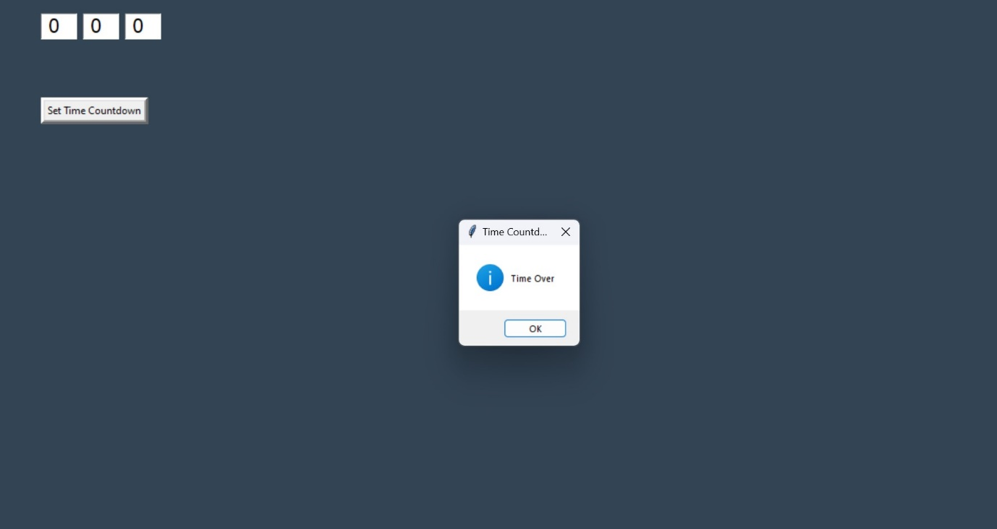

CHAPTER 7

RESEARCH GAP

1. Research gaps in the field of countdown timers and clocks necessitates a careful analysis of the body of current literature as well as user demands and technical developments.
2. Even though countdown clocks and timers have been researched and developed in great detail, there are still a number of areas that need more research to fully handle new possibilities and obstacles.
3. Among the possible areas for further study in this area are:

* Interaction design and user experience
* Personalization and Adaptation
* Integration with IoT and Smart Devices
* Accurate Time Management
* Inclusivity and Accessibility
* Effect on Well-Being and Productivity
* Data security and privacy

CONCLUSION:

We are finally concluding that countdown clocks and timers is still to constantly innovate and adjust to the shifting demands and expectations of people as we move forward. In order to provide predictive capabilities, tailored experiences, and seamless connection with other smart devices and services, this involves integrating cutting-edge technology like artificial intelligence, machine learning, and the Internet of Things. The ultimate objective is to provide people with the means by which they can make the most of their time, accomplish their objectives, and enjoy more fruitful and satisfying lives.  
  
To sum up, countdown clocks and timers are essential tools for task monitoring and time management that help users stay focused, productive, and organized. These tools are well-positioned to continue being extremely helpful due to their continuous invention and evolution.

REFERENCES:

1. Campbell, G. K. et al. The absolute frequency of the 87Sr optical clock transition. Metrologia 45, 539 (2008).
2. Bothwell, T. et al. Resolving the gravitational redshift within a millimeter atomic sample. Nature https://doi.org/10.1038/s41586-021-04349-7 (2022).
3. Boulder Atomic Clock Optical Network (BACON) Collaboration. Frequency ratio measurements at 18-digit accuracy using an optical clock network. Nature 591, 564–569 (2021).
4. Li C, Li Z, Li T, Li C and Wang B. A Deterministic Embedded End-System Tightly Coupled With TSN Schedule. IEEE Transactions on Computer-Aided Design of Integrated Circuits and Systems. 10.1109/TCAD.2023.3248500. 42:11. (37073719)
5. E.Lagnf F and Ganesan S. (2022). The Improved Implementation of the Message freshness on CAN XL using FPGA 2022 IEEE International Conference on Electro Information Technology (eIT). 10.1109/eIT53891.2022.9813763. 978-1-6654-8009-3. (215-220).
6. Nguyen V, Nguyen T and Jeon J. An Adaptive Fuzzy-PI Clock Servo Based on IEEE 1588 for Improving Time Synchronization Over Ethernet Networks. IEEE Access. 10.1109/ACCESS.2020.2983421. 8. (61370-61383).
7. D. Dolezilek, "Ethernet Design for Teleprotection and Automation Requires a Return to First Principles to Improve First Response", proceedings of the 14th Annual Western Power Delivery Automation Conference, March 2012.
8. E. O. Schweitzer, D. Whitehead, S. Achanta and V. Skendzic, "Implementing Robust Time Solutions for Modern Power Systems", proceedings of the 14th Annual Western Power Delivery Automation Conference, March 2012